Business Math
Tax Simulation #1

Instructions: Use the information provided to fill out the W-4 form for Lawrence Red Owl.

- Your name is Lawrence Red Owl.
- You have just recently graduated from college with a marketing degree.
- On the 1st of next month you will start your new job as manager of a clothing store in a mall.
- You will get a weekly salary plus a bonus based on the store’s sales.

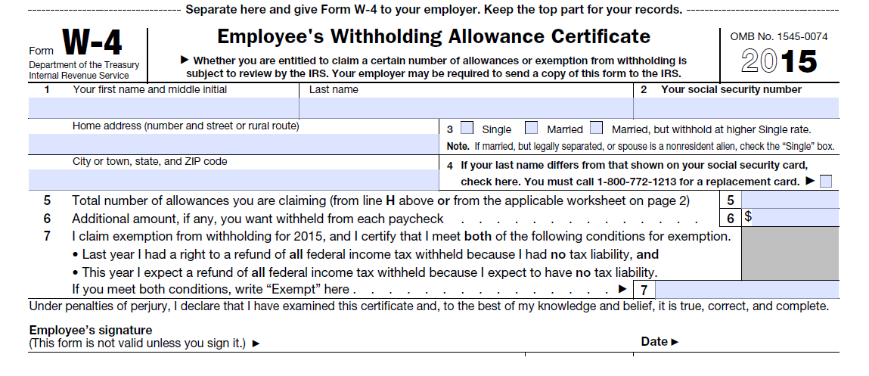
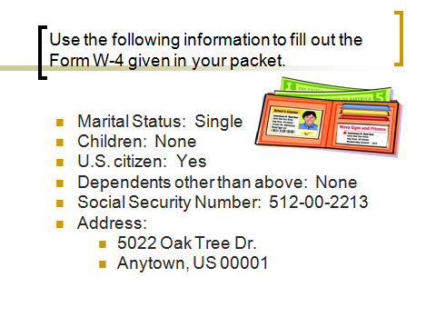

Review Questions
Answer the following multiple-choice and true/false questions about payroll taxes and federal income tax withholding by clicking on the correct answers. To assess your answers, click the Check My Answers button at the bottom of the page.
- The Social Security tax rate is
- A. 1.45%
- B. 6.20%
- C. 7.65%
- Employees send their payroll taxes directly to the federal government.
- A. True
- B. False
- Employers use which form to compute the amount of federal income tax to withhold?
- A. Form W-4
- B. Form W-2
- C. Form 1040EZ
- Gross pay is the amount of pay the employee takes home.
- A. True
- B. False
- Who completes Form W-4?
- A. Employer
- B. Employee
- C. IRS

