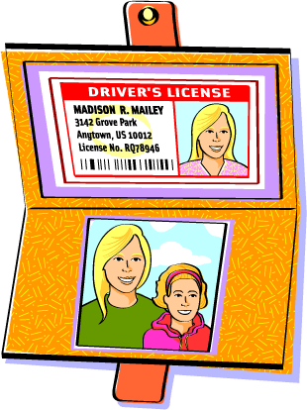
Business Math
Tax Simulation 7

Fill out a 1040 for Madison Mailey

- You are Madison Mailey
- Your social security number is 222-00-4444
- You are a caterer
- You are single with one child, Robyn, age 7 (SS# 222-00-2222)
- You are both U.S. Citizens
- You will use the Head of Household Filing Status
- You provided all of the support for Robyn
- You will have $473 credit for child and dependent care expenses. (Line 49)
- You have a Child Tax Credit of $1000 (Line 52)
- On line 44, use the tax tables from the IRS website: irs.gov, link is provided in Google Classroom
- Any refund you would like direct deposited into your checking account: Routing # 987654321 and Account # 987987987987

- Your address is 3142 Grove Park,
Anytown US 10012

Assume you have no other income except what is on the W-2 form.
