Business Math
Tax Simulation #3

You will be given 3 Profiles. You must decide if each person can claim the dependent. Do these on your own.
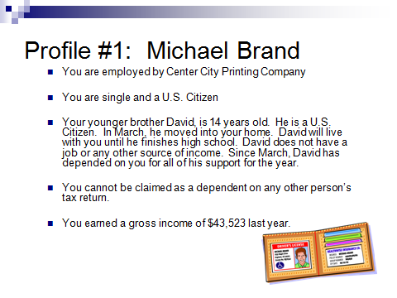
Dependency Tests for David
- Relationship Test yes or no
- Citizen or Resident Test yes or no
- Joint Return Test yes or no
- Age Test yes or no
- Support Test yes or no
- Residency Test yes or no
- Can you claim David as a dependent on your tax return? yes or no

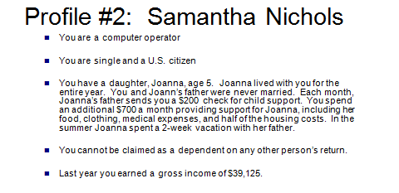
Dependency Tests for Joanna
- Relationship Test yes or no
- Citizen or Resident Test yes or no
- Joint Return Test yes or no
- Age Test yes or no
- Support Test yes or no
- Residency Test yes or no
- Can you claim Joanna as a dependent on your tax return? yes or no
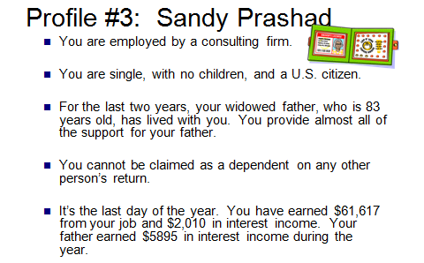

Dependency Tests for Your Father
- Member of Household or Relationship Test yes or no
- Citizen or Resident Test yes or no
- Joint Return Test yes or no
- Gross Income Test yes or no
- Support Test yes or no
- Can you claim your father as a dependent on your tax return? yes or no

