Business Math
Tax Simulation #2

Instructions: Use the information provided to fill out 1040 EZ form for Cicely B. King.

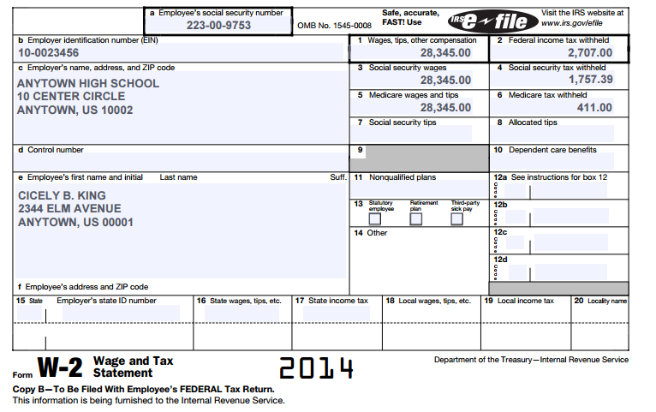

Review Questions
Answer the following multiple-choice questions about wage and tip income by clicking on the correct answers. To assess your answers, click the Check My Answers button at the bottom of the page.
- The Wage and Tax Statement is also known as
- A. Form W-2.
- B. Form 1040EZ.
- C. Form W-4.
- D. None of the above
- Which of the following is true?
- A. Only tips paid in cash are taxable.
- B. Only tip income reported on Form W-2 is taxable.
- C. Tip income is not taxable.
- D. All tip income is taxable.
- Which of the following is not reported on Form W-2?
- A. Wages, tips, and other compensation
- B. Federal income tax withheld
- C. Medicare tax withheld
- D. The number of withholding allowances claimed by the employee on Form W-4

