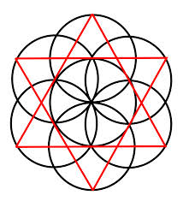
History of Geometry
Start at the following website:
http://www.kidsmathgamesonline.com/facts/geometry/history.html
This will give you some basic facts about the history of geometry. Answer the following questions:
- Where does the word “Geometry” come from.
- Who is considered the “Father of Geometry”?
- What other ancient civilizations besides the Greeks used Geometry?
- What were the most important tools in the advancement of Geometry?
Now go to this website about circles. Answer the following circle questions.
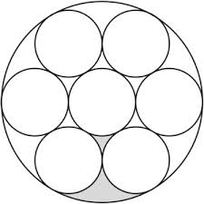
http://www.kidsmathgamesonline.com/facts/geometry/circles.html
- What is an arc?
- What is a cord?
- How many degrees does a semi-circle have?
- Name at least one more circle fact you learned at this website.
Now go to this website about spheres and answer the following questions.
http://www.kidsmathgamesonline.com/facts/geometry/spheres.html
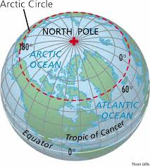
- What is the definition of a sphere?
- How do you find the volume of a sphere?
- Is the Earth a sphere?
- Name at least one more sphere fact.
Now go to this website about the history of π and answer the following questions.
http://www.exploratorium.edu/pi/history_of_pi/
- What was the first civilization know to use the value of π?
- What ancient Greek mathematician is credited with calculating π?
- When did mathematicians start using the symbol π to represent the circumference of a circle divided by its diameter?

